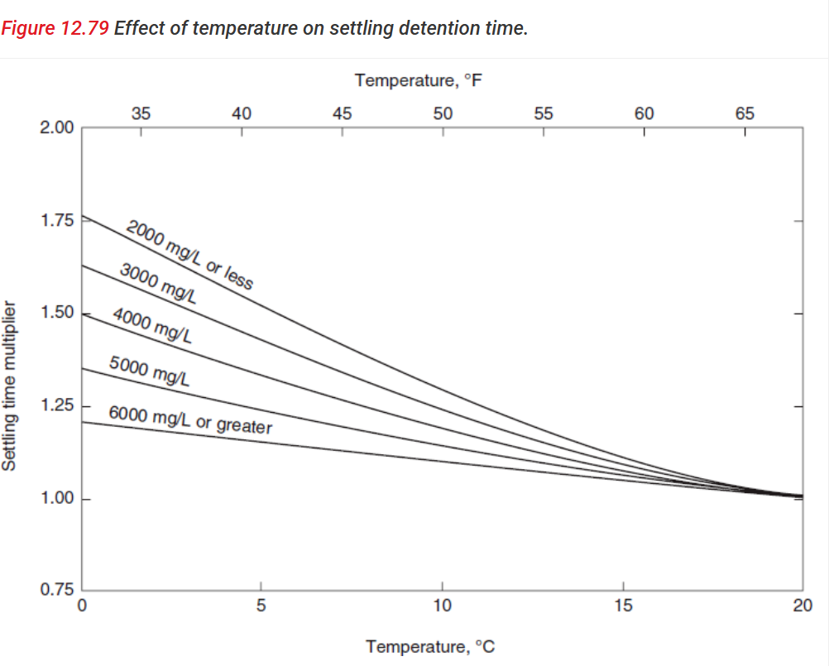
Temperature of wastewater in winter. That would be the worst case scenario.
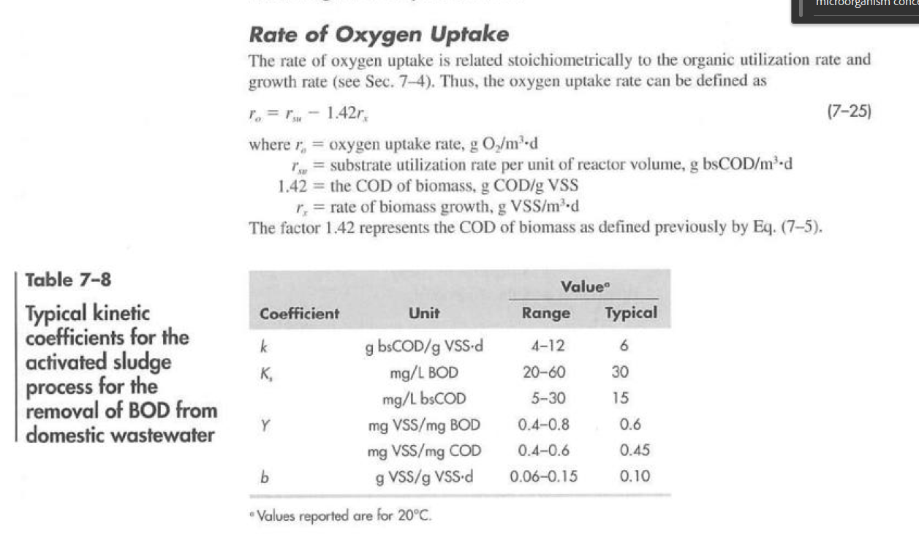
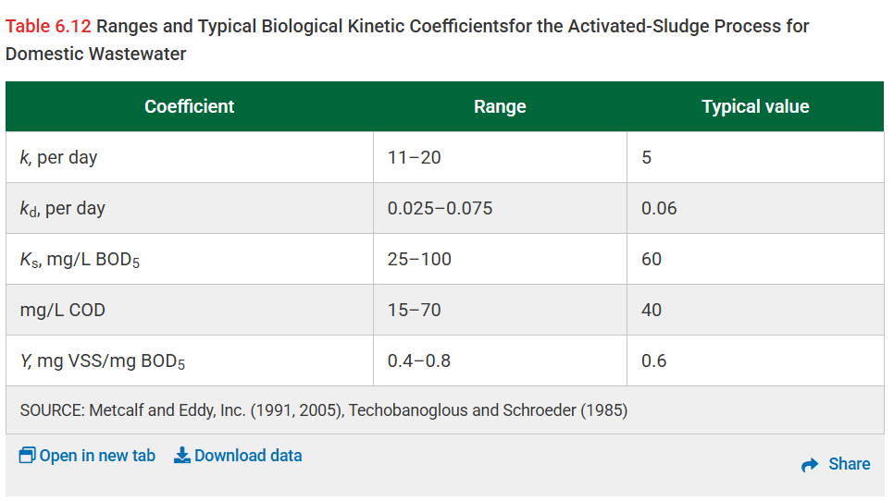

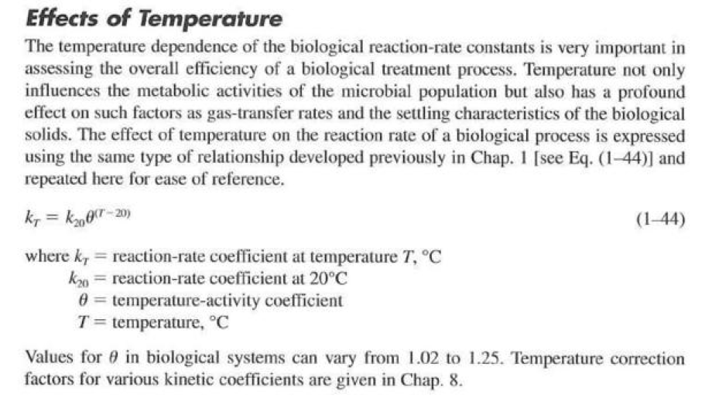

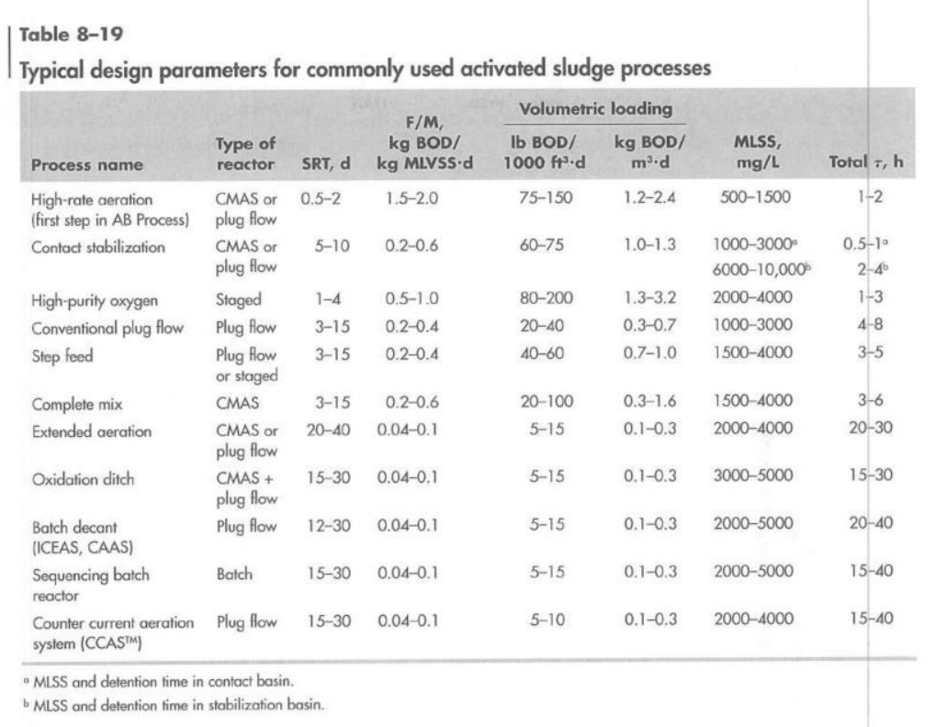

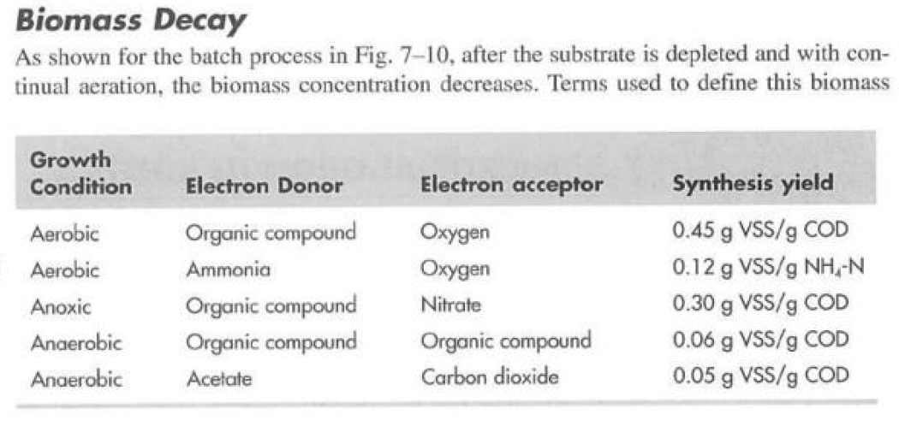

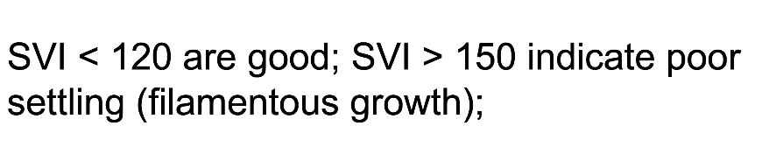

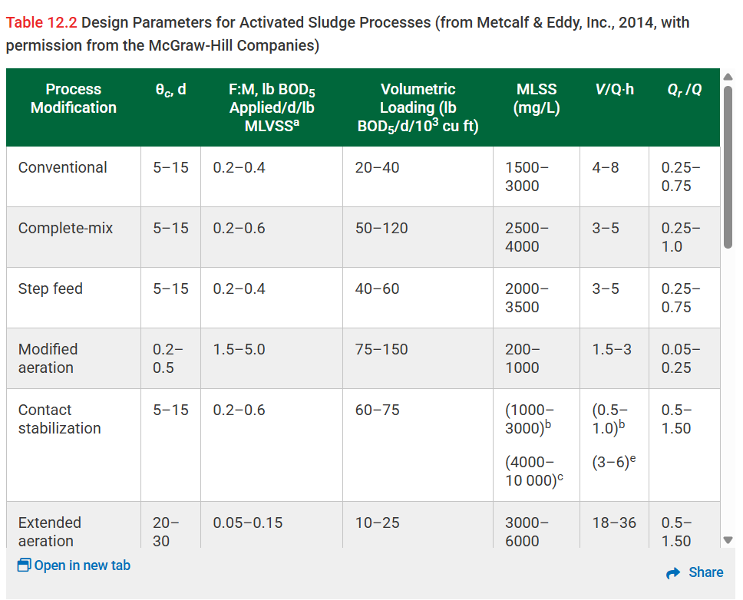

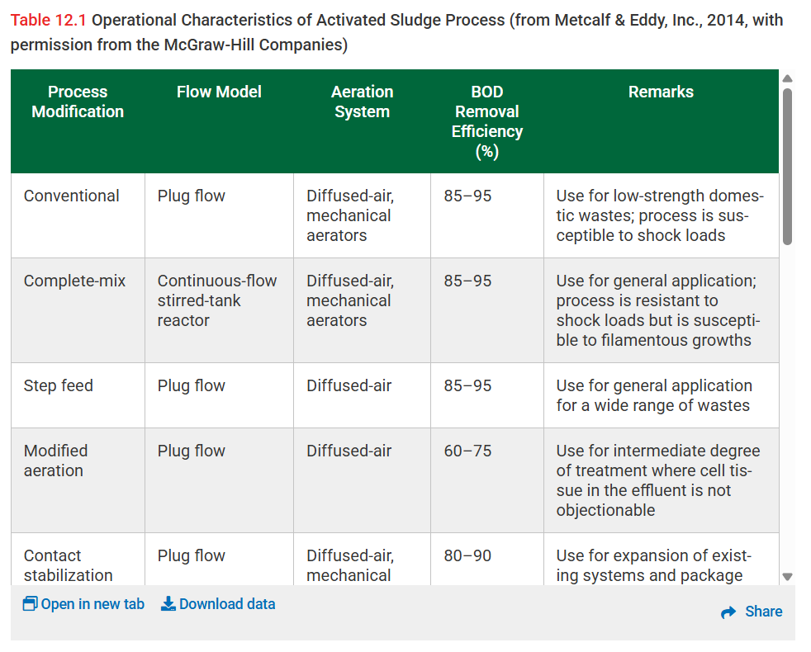

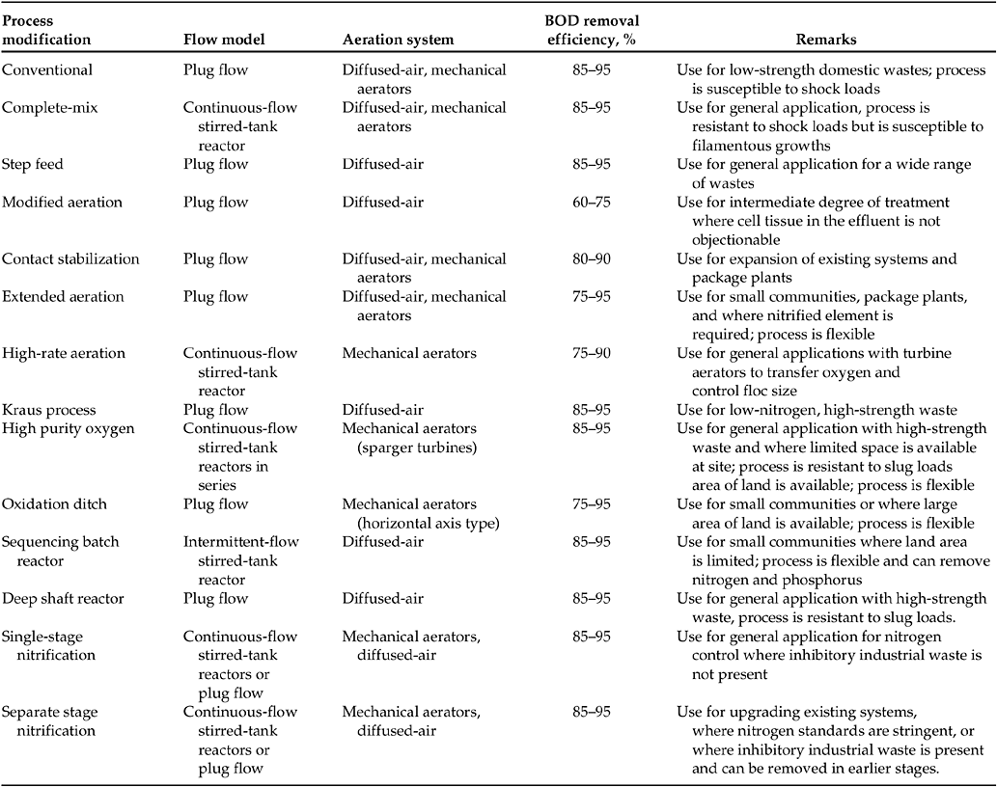
Table 14.3 Design parameters for activated sludge processes (from Metcalf & Eddy, Inc., Wastewater Engineering: Treatment and Reuse, 4th Ed., R. Tchobanoglous [Ed.], Copyright © 2003, with permission from the McGraw-Hill Companies). Water Environment Federation. 2010. “PROCESS CONFIGURATIONS AND TYPES.” Chap. 2.0 in Design of Municipal Wastewater Treatment Plants: WEF Manual of Practice No. 8 ASCE Manuals and Reports on Engineering Practice No. 76, Fifth Edition. Fifth. New York, Chicago, San Francisco, Lisbon, London, Madrid, Mexico City, Milan, New Delhi, San Juan, Seoul, Singapore, Sydney, TorontoNew YorkChicagoSan FranciscoLisbonLondonMadridMexico CityMilanNew DelhiSan JuanSeoulSingaporeSydneyToronto: McGraw-Hill Education. https://www.accessengineeringlibrary.com/content/book/9780071663588/toc-chapter/chapter14/section/section7

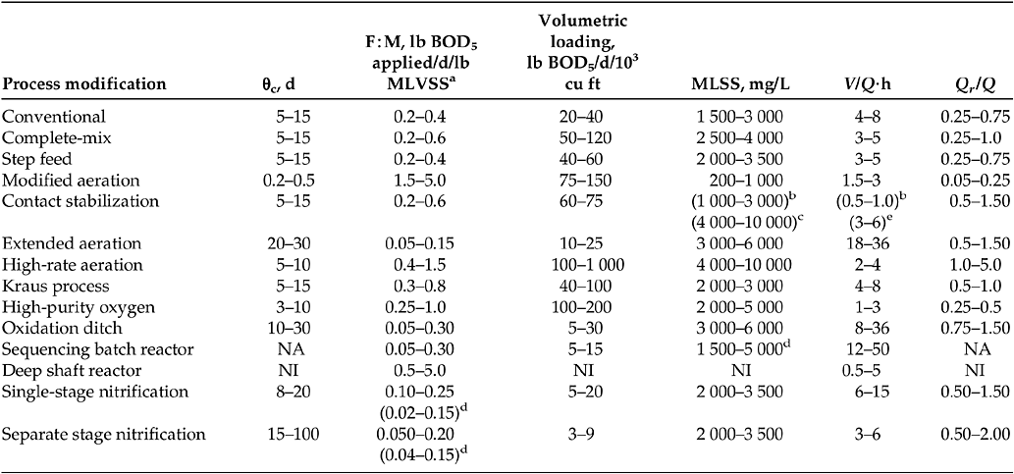

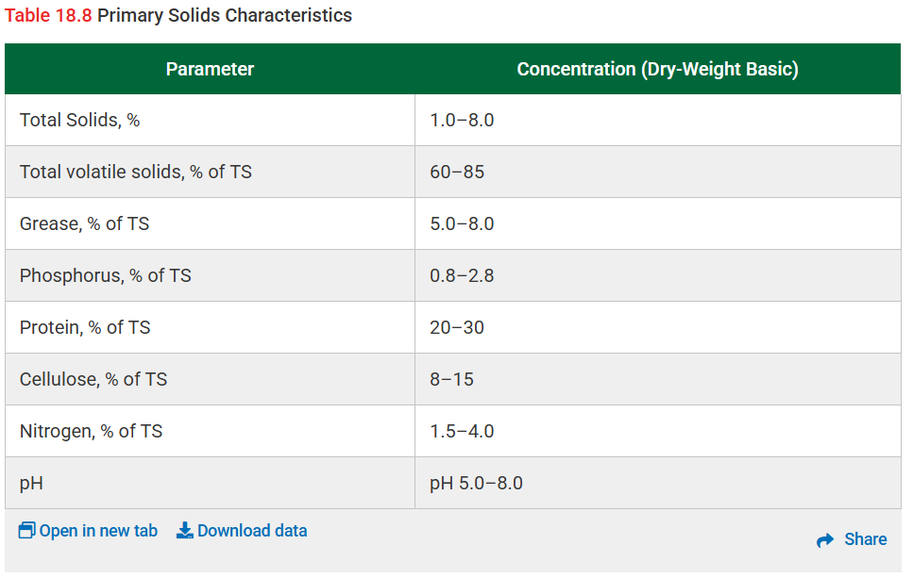
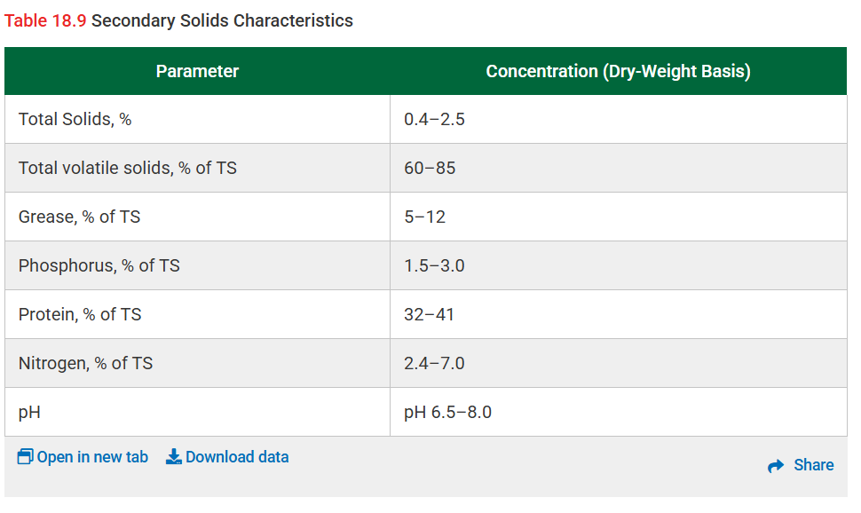
Design of Water Resource Recovery Facilities, 6th Edition

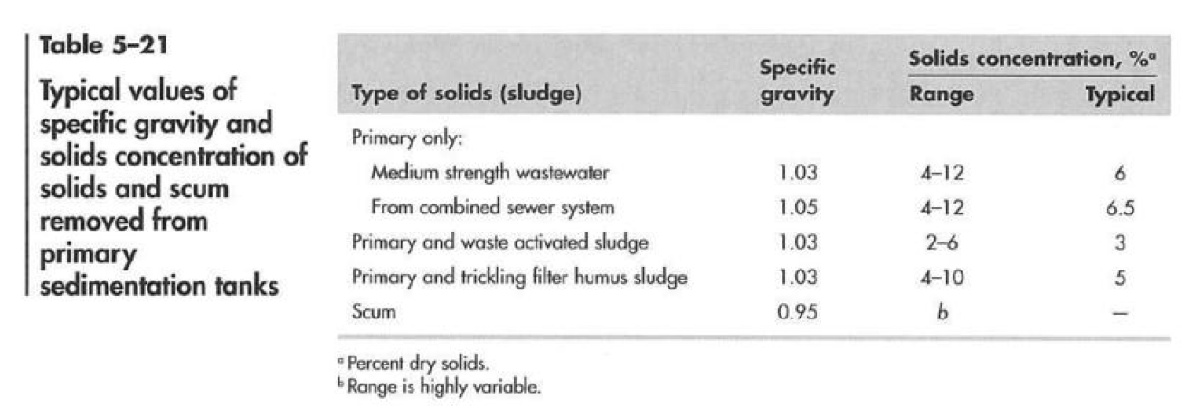

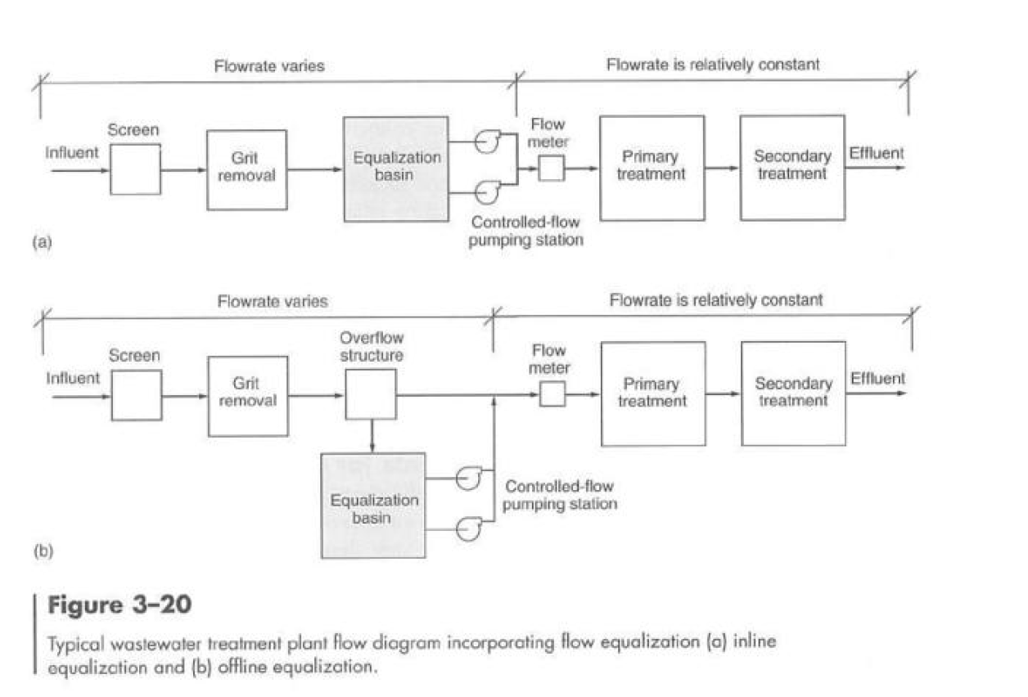

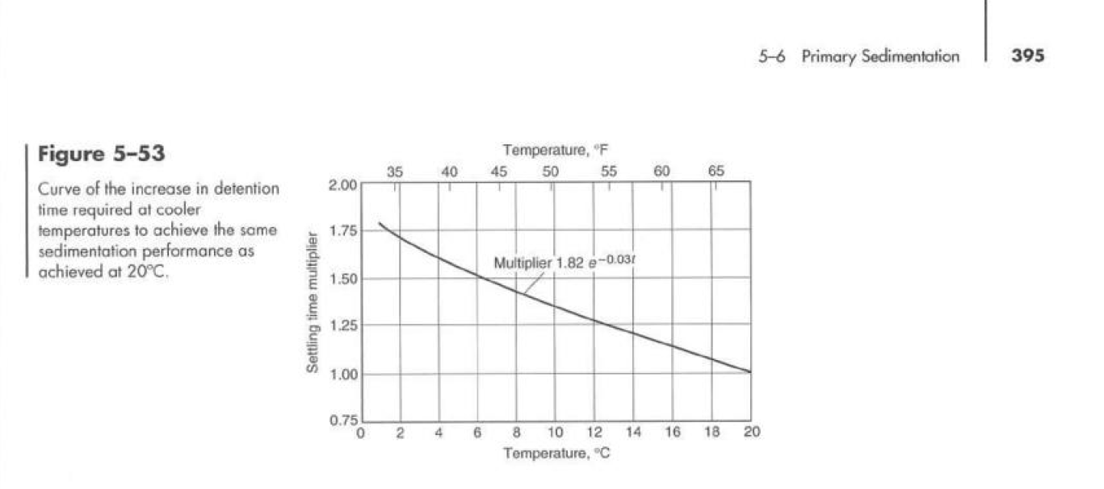
Tiempo

2 Preliminary Treatment
2.1 Facility Types
Coarse screens designed to retain gross pollutants greater than 10 mm are proposed to effectively protect downstream treatment processes. These screens, commonly employed in wastewater treatment plants (WWTPs), efficiently remove large solids, rags, and debris (Davis, 2010). However, it is noted that their contribution to the removal of biochemical oxygen demand (BOD) is considered negligible.
Each mechanical screen unit should be installed in its own dedicated channel, facilitating isolation for maintenance or emergency purposes. Additionally, vortex grit chambers are proposed to remove grit particles up to 100 mm. This inclusion significantly reduces grit accumulation in downstream units and prevents sediment buildup within the equalisation basin, thus enhancing the overall reliability and effectiveness of subsequent treatment processes.
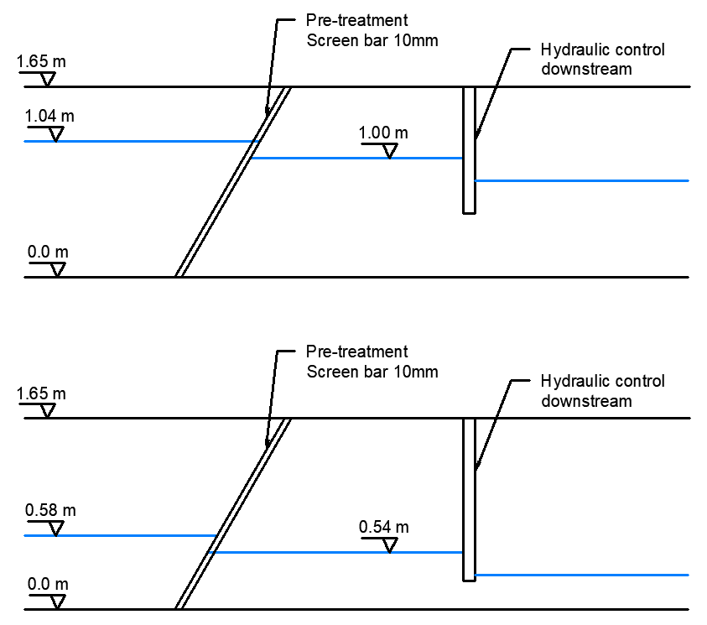
2.2 Screens Design
Calculation Details and Parameter Justification:
According to Davis (2010), the channel approach velocity upstream of the screens should be at least 0.4 m/s to minimize solids deposition. Conversely, the maximum velocity through the screens should not exceed 0.9 m/s at peak flow conditions, to avoid forcing debris through the bars and maintain screening effectiveness.
The channel dimensions have therefore been carefully selected to comply with these recommended minimum and maximum velocities. Specifically, calculations were performed to ensure operational velocity remains within these constraints under the expected peak flow conditions.
A 50% blockage condition at peak flow is assumed for design calculations. This conservative approach allows sufficient margin to ensure operational reliability and gives operators adequate time to perform maintenance before significant performance issues occur.
Operational Considerations:
Velocity Selection:
A target velocity of 0.7 - 0.9 m/s at peak flows is ideal for operational balance, ensuring effective screenings removal without excessive turbulence or debris bypass.
Channel Dimensioning:
Channel width and depth are sized to maintain appropriate flow velocities under varying conditions, considering future growth scenarios and possible peak events.
Maintenance Implications:
Screens should be easily accessible and designed for rapid maintenance response. Scheduled inspections and routine cleaning are required, particularly following high flow events.
2.3 Equalisation Basin Purpose and basic dimensions (reference to primary clarifier calculations).
The equalisation basin was designed to minimise flow fluctuations to downstream treatment units, enhancing overall plant stability and performance. Initially, the basin volume calculated by capturing all inflows exceeding the projected average daily flow resulted in an impractical tank size (~24,000 m³). Therefore, a new peak flow of 138,626 m³/day was established, based on the maximum capacity of the downstream primary treatment facilities. (See section primary treatment)
This revised approach operates near-average flow rates for most hours of the day. During peak inflow periods (from 3 pm to 9 pm), inflows exceeding this new peak flow rate are diverted to the equalisation basin. In low-demand hours, stored wastewater is returned to maintain less variable flow to the downstream processes. This method reduced the required equalisation volume and significantly reduced the peak flows. After recalculating using this approach, the required equalisation volume was smaller, although this requires extra operational control, providing narrower variation in the hydraulic regime for downstream processes.
This equalisation basin requires aeration so as to prevent odours and solids deposition. The proposed equalisation is an off-line basin as seen in the diagram below:
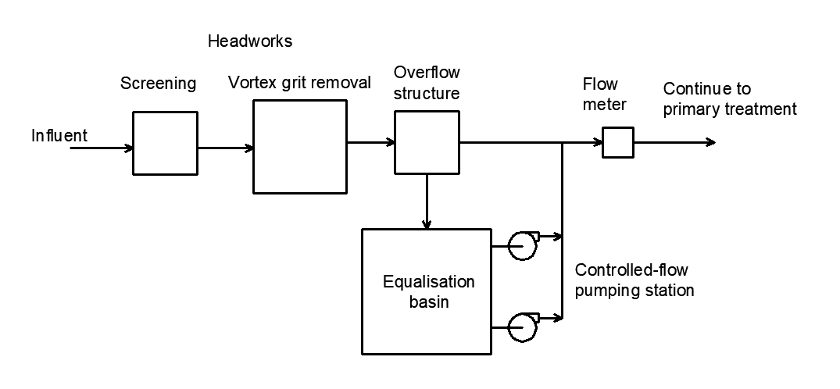
Off-line equalisation basin –adapted from Fig 3-20, Davis,2010
2.4 Protection Against Failure
The preliminary treatment facilities incorporate redundancy and safety features to protect against failure scenarios and to ensure continuous operation. These recommendations are described in Davis, 2010:
Redundancy Measures:
An additional mechanically cleaned coarse screen and vortex grit chamber unit will be provided as backup units. This ensures operational continuity during periods when primary units are undergoing maintenance or experiencing overloading conditions.
Bypass Channels and overflow:
Dedicated bypass channels will be installed, allowing flows to bypass the primary screening and grit removal facilities as well as overflow outlet should be provided for equalisation basin. These measures are useful in emergency situations, preventing hydraulic overload
Maintenance Accessibility:
Screens, grit chambers and equalisation basin are designed with ease of access in mind, facilitating rapid maintenance and emergency interventions.
Emergency Procedures and Alarms:
An alarm system is designed to trigger when blockage levels reach 50% or if there is a sudden halt in mechanical operation. This proactive alert mechanism allows prompt operator intervention, minimizing risks of overflow or downstream process damage.

